22
Joint action plan for environmental management and monitoring for disaster risk reduction
Implement Smart Policies for Management, Monitoring and Environmental Prevention
Sonja Popović and Nataša Jović

Table of Contents
1. INTRODUCTION 3
2. OWERVIEW OF THE MUNICIPALITIES 5
2.1. Municipality of Kostinbrod 5
2.2. Municipality of Trgovište 10
3. LEGAL FRAMEWORK FOR DISASTER RISK REDUCTION IN CROSS BORDER REGION 14
3.1. Legal framework for Disaster risk reduction in Republic of Serbia 14
3.2. Legal framework for Disaster risk reduction In Republic of Bulgaria 16
4. ENVIRONMENTAL MANAGEMENT FOR DISASTER RISK REDUCTION 18
4.1. Disaster risk reduction and management 18
4.2. Disaster Risk Reduction and Environmental Monitoring 20
5. MOST FREQUENT NATURAL DISASTERS IN CROSS – BORDER REGION 22
5.1. Floods 22
5.2. Flash flood and soil erosion 24
5.3. Climate change 25
5.4. Fires and wildfires 26
5.5. Earthquakes 27
6. SWOT ANALYSIS 29
7. PRIORITIES OF THE JOINT ACTION PLAN 32
8. ACTION PLAN FOR PERIOD 2022 – 2027. 34
8.1. Urban Environment Sector 34
8.2. Biodiversity and Ecosystems Sector 35
8.3. Waste management in Trgovište 37

INTRODUCTION

In the last 30 years, the number of disasters in the world has increased, as well as the devastating effect they have on society and the environment. The frequent occurrences of natural disasters, especially flooding become one of the most alarming problems. We are witnessing that global climate change is one of the main culprits in increasing the frequency of such events. The Region of Southeast Europe is often threatened by various types of natural hazards (floods, droughts, earthquakes, extremely high temperatures, landslides, etc.), technical and technological accidents, hazardous materials and other hazard conditions.
Dealing with disasters in earlier period focused primarily on emergency response, but recently it was acknowledged that disasters should be tackled only by reducing and managing conditions of hazard, exposure and vulnerability that we can prevent losses and alleviate the impacts of disasters. The main opportunity to reduce risk is to manage the risk itself, by managing conditions of hazard, exposure and vulnerability in order to prevent losses and alleviate the impacts of disasters. The severity of natural hazard is hard to reduce, but the opportunity to reduce risk lies in reducing vulnerability and exposure.
Humanity began to realize that natural disasters must be lived with, but that it is important to know that the consequences of disasters can be significantly reduced if people are well informed and familiar with the way disasters are prevented. Disaster risk reduction and climate change adaptation are among key activities for reducing the vulnerability of communities.
The Sendai Framework for Disaster Risk Reduction 2015-2030 (Sendai Framework) was the first major agreement of the post-2015 development agenda which provided concrete actions to protect development gains from the risk of disasters. The Sendai Framework works hand in hand with the other 2030 Agenda agreements, including The Paris Agreement on Climate Change, The Addis Ababa Action Agenda on Financing for Development, the New Urban Agenda, and ultimately the Sustainable Development Goals.
Resilience is often recognized as a key factor of an effective urban system. Cities are increasingly exposed to multiple shocks and stresses beyond disasters, ant it is crucial to involve the communities in all the measures to prevent disasters.
An integrated approach to natural resource management is a process which promotes coordinated development and resource management, in order to maximized economic and social well-being without compromising the sustainability of vital ecosystems. This approach should integrate research on different types of natural resources into processes adaptive governance and stakeholder-driven innovation, how would improve lifestyles, ecosystem resilience, resource productivity and environmental services in the community, but also in the eco-regional and global level of intervention and influence.

OWERVIEW OF THE MUNICIPALITIES

Municipality of Kostinbrod

The municipality of Kostinbrod is situated in Republic of Bulgaria, in the Sofia field in the immediate vicinity of the capital in a valley of about 1200 km2, with an average altitude of 550 m.
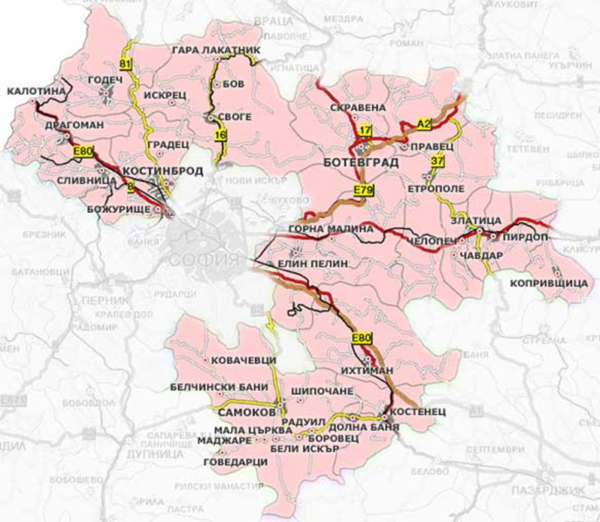
Figure 1. Territorial location of Kostinbrod municipality (Source: Environmental Protection Programme of Kostinbrod Municipality 2016-2020)
Kostinbrod Municipality includes within its borders 14 settlements, the largest of which are the administrative center - the town of Kostinbrod, the settlement Petarch and village Dragovishchitsa.
The territory of Kostinbrod municipality covers an area of 254 239 acres, the "Settlements" fund occupies 24 052 acres, which constitutes 9.5% of the total area, the agricultural fund occupies 167 987 acres and the forestry fund - 62 200 acres of the total territory of the municipality.
Relief: The active endogenous and exogenous forces have contributed to the formation of the modern relief on the territory of the municipality of Kostinbrod. Karst has played an important role in the development of the relief, and karst processes have been particularly strong in the western part, leading to the formation of surface and sub-surface karst in the area of the village of Gradets. The territory of the municipality includes parts of the Mala Planina mountain as well as parts of the Sofia valley. The highest point is 1155 meters, and the average altitude of Kostinbrod municipality is 725 meters.
Climate characteristics: The territory of the municipality belongs to the temperate-continental climatic area of the country. The climate is influenced by temperate oceanic air masses invading from the north-west and, less frequently, by temperate continental air masses invading from the north-east. The Stara Planina mountain has a major influence on the climate of the municipality of Kostinbrod. It is Kostinbrod's basin-like geographical location and the surrounding mountain ranges that contribute to the formation of inversions. Total solar radiation is also a contributing factor to the climate of the territory, which ranges from 1750 to 2000 MJ/m²/year. The average annual temperature in the region is 9.7 Celsius degrees, and the average annual rainfall is between 590 - 600 mm.
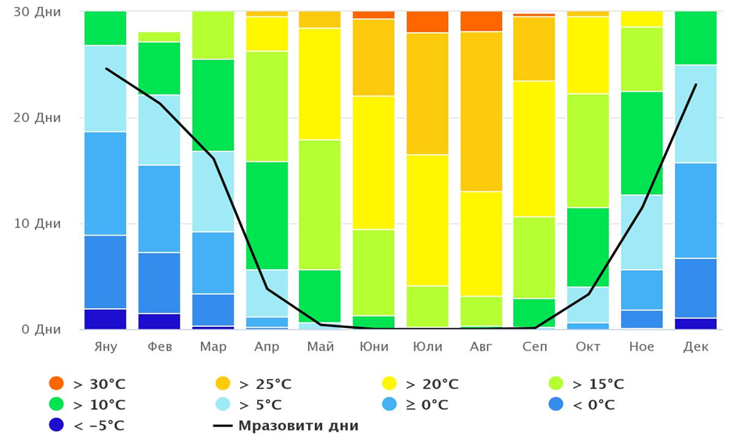
Figure 2. Maximum monthly temperatures in Kostinbrod municipality
(Source: https://www.meteoblue.com/)
Hydrological characteristics: Through the territory of the municipality flow the rivers Blato, Belichka and Slivenishka, which are tributaries of the river Iskar. Another river passing through the territory of the municipality is the river Kriva, which rises from the Mala Planina mountain and is a tributary of the Iskar river. The rivers in the municipality have a spring high water in April and May and a pronounced winter and summer minimum. The density of the river network in Kostinbrod municipality is 1.5-2 km/km². The runoff modulus is 5-7,5 l/s/km, the highest being in spring 5-7,5 l/s/km and the lowest in summer and autumn 3-4 l/s/km, as stated in the Master Plan of Kostinbrod Municipality.
The Water Framework Directive (WFD) introduces a new approach to water management by introducing environmental standards and quality objectives that ensure the structure and functioning of aquatic ecosystems. In terms of water management, the territory of Kostinbrod municipality falls within the territory of the Danube Basin Directorate with its centre in Pleven.
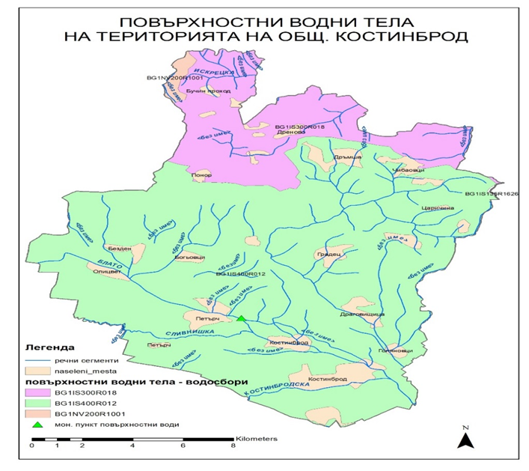
Figure 3. River network in Kostinbrod municipality (Source: Environmental Protection Programme of Kostinbrod Municipality 2016-2020)
Dams: There are several dams on the territory of Kostinbrod municipality: Bezden, Maslovo, Bistritsa an others.
The Besden dam consists of an earth fill dam, a small head spillway, a main outlet - a water intake shaft and pipeline, a spur to the pumping station and a pumping station. The body of the dam is a monolithic earth embankment. An agricultural road runs along the crest of the wall, linking the village of Bezden to the agricultural land. The reservoir is filled with water from the karst spring 'Bezden', located next to the reservoir. Bistritsa dam is filled with water from several karst springs.
The Maslovo Dam is located outside the town's zoning plan. It is located in the outskirts of the town. It was built in 1968 and has an area of 86,934 acres. The dam is used as a reservoir for irrigation and sport fishing. The source of water supply is a nearby small river and surface runoff. Its method of filling is gravity.
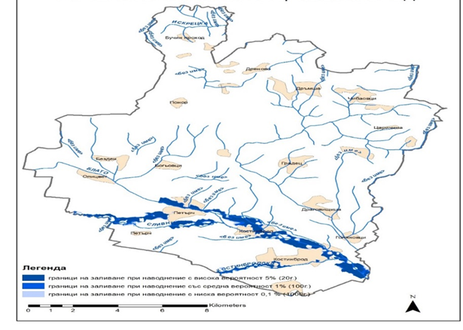
Figure 4. Potential flood area in Kostinbrod municipality (Source: Environmental Protection Programme of Kostinbrod Municipality 2016-2020)
Potential flood areas are the sections of the river Blato from the village of Petarch upstream; Slivenishka from the village of Petarch to the town of Slivnitsa and the Blato river from the confluence of the Slivenishka river to its confluence with the Iskar river.
High risk is identified for the town of Kostinbrod and areas with potential flood risk are identified for the village of Petarch.
Kostinbrod Municipality previously implemented a project proposal under grant scheme BG 161PO001/1.4-06/2010 "Support for small-scale flood prevention measures in urban agglomerations" due to the fact that the riverbed of the Blato river in the area of the town of Kostinbrod was flooded. The situation in the area was very poor. The banks of the river were heavily overgrown with vegetation and no correction works had been carried out along the entire route in the settlement, resulting in a number of properties and homes being flooded during heavy snowmelt and rainfall.
The project has achieved the following:
• Improved maintenance of 1,711 km. of river channel with a stable and strengthened profile to conduct high waters;
• Flood risk is minimised;
• Better security of over 750 residents along the Blato river in the town of Kostinbrod is ensured;
• The overall ecological status of the area is improved.
As a consequence of intense, prolonged rainfall, heavy snowmelt and runoff of water from agricultural areas to urban areas in a complicated meteorological situation in winter conditions, in the period from 07.01.2021 to 11.01.2021 unusually and uncontrollably high waters were formed in and out of the beds of all rivers in the municipality of Kostinbrod, including the river Slivniviska, which are the cause of the "crisis".
In order to cope with the crisis, Kostinbrod Municipality's Disaster Protection Plan - Part "Flood Protection" was put into action.
The Headquarters for the Implementation of the Municipal Disaster Protection Plan, in cooperation with the National Headquarters and the Departmental Headquarters for the Implementation of the National Disaster Plan and the Headquarters for the Implementation of the District Disaster Protection established objective impossibility to overcome the floods. The decision was made to declare a state of emergency on the affected parts of the territory of the municipality of Kostinbrod, to undertake rescue and urgent emergency works to overcome the critical situation, threatening directly and immediately the life, health and property of the population.
As a result and as a consequence of the measures taken by the State, the following activities have been implemented:
  - Rescue, emergency and urgent emergency works on the river "Slivenishka";
  - Emergency and Urgent Emergency Works to clean up land along the Blato river;
  - Rescue, Emergency and Urgent Response works were conducted at Dere street in village of Golianovitsi;
  - Rescue, Emergency and Urgent Response works were conducted on the Blato river.

Municipality of Trgovište

The municipality of Trgovište is located in Republic of Serbia, the Pčinja district, covering an area of ​​368 km². It stretches along the border with Macedonia, and borders the municipalities of Bosilegrad, Vranje and Bujanovac. The very centre of the municipality, the town of Trgovište, is located at the confluence of three rivers: Tripušnica, Kozjedolska and Lesnička, from which the river Pčinja is formed, which flows into Vardar. It is located at 42°22′N 22°05′E.
Relief: The configuration of the terrain is a typical rural hilly-mountainous area surrounded by mountains and plateaus: Beli Vode, Zladovačka planina, Anište, Golemi vrh, Lesnica, Kopljača, Petrova Gora, and in the interior there is a high surface intersected by valleys of fast mountain rivers Tripušnica, Kozjedolska river, Lesnicka, Mala, as well as the main river Pcinja. The ratio of the lowest and highest altitude is 520 m-1,828 m (difference 1,308 m).
Climate characteristics: The municipality is characterized by a temperate-continental climate, characterized by fresh and shorter summers, with longer and more severe winters. The average monthly temperatures in January and February are negative, and the other months have positive values. Winds from all directions are represented. The north-eastern winds are among the most common and strongest. The amount of precipitation in certain parts of the area during the year ranges from 600 to 1200 mm. The hail storms have a very common occurrence, and most often occurs in the period from May to August.
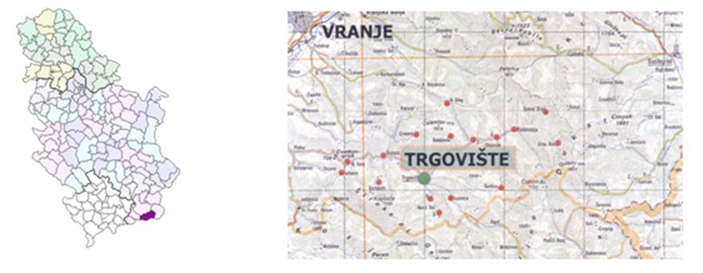
Figure 5. Municipality of Trgovište (Source: website of the Municipality of Trgovište)
Hydrological characteristics: The area to which Trgovište belongs is characterized by a dense river network. The main river is Pčinja, a left tributary of the river Vardar. Pčinja originates from several streams on the western slope of the Dukat mountain near the village of Radovnica, from where it flows further west under the name Tripušnica. Near the settlement of Trgovište, the Lesnička river flows into Tripušnica from the south, from where the river flows further west under the name Pčinja. Pcinja then flows west of the Široka mountain. Near the village of Šajince, it receives the right tributary Koćurica and continues to the south through a narrow valley between the mountains Rujen and Kozjak.
Besides Pčinja, there are Tripušnica, Lesnička, Kozjedolska, Mala and Koćurska river. Tripušnica springs on the slopes of Doganica, near the village of Crna Reka at 1480m. The source of the Lesnička river is at an altitude of 1450 m on the slope of the Čupina mountain, and the Kozjedolska river near the village of Nerava, at an altitude of 1430 m. Mala river is a left tributary of Pčinja with a source near the village of Dlabočica on the border of Kozjak and Đermanska mountain, while the source of Koćurska river (right tributary of Pčinja) is located on the mountain of the same name, near the village of Nova Brezovica.
The area to which the Municipality belongs is characterized by frequent floods, which mostly occur in the spring. The floods are most often on the river Pcinja and Kozjedolska river, and the least on Tripusnica.
The hydrographical network in the area of ​​Trgovište is very developed. All watercourses in the area of ​​Trgovište belong to the category of torrent watercourses.
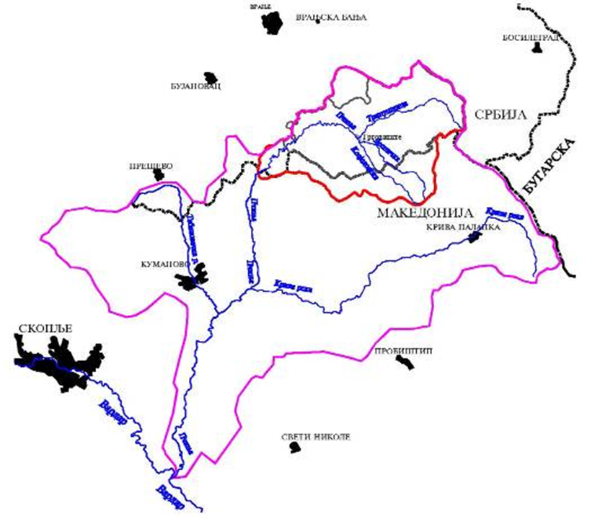
Figure 6: Pcinja River Basin (Source: OPERATIONAL PLAN FOR DEFENSE AGAINST FLOOD ON WATERS OF THE TYPE II ON THE TERRITORY OF THE MUNICIPALITY OF TRGOVIŠTE FOR 2021)

The upper parts of the basins of most torrents belong to hilly areas, with relatively large falls of the basin and riverbed. While the lower streams are located in the lowland zones, the valleys of the rivers into which torrents flow. As the fall of the river basin is high, great waters are formed. As for the geomorphological condition of the terrain, it consists of rocks that are affected by the processes of degradation and surface decomposition, thus creating a good basis for the development of leaching and ravine formation. Such processes have led to the formation of a large number of ravines and narrow stream valleys with constant surface flows that in the period of intense precipitation or melting snow turn into torrents.
Tectonic predisposition of the terrain, expressed in the appearance of assumed and determined fault structures, also contributes to the development of these erosion processes. In the valley of the river Pčinja and its tributaries, a narrow alluvial plain was formed, i.e. a valley built of large gravelly-sandy and voluminous material. Petrographically, this material was created by the mechanical work of the river flow of the river Pčinja and its tributaries, and which mineralogical belongs to the surrounding rocks. The production of this sediment is very pronounced in places where the transport power of the stream decreases. All these phenomena indicate the erosion of the river flow, as well as the erosion of the river basin, which requires the implementation of anti-erosion measures and field work.
The watercourses on the territory of the municipality of Trgovište are mostly with a torrential hydrological regime. Floods on these watercourses are specific, because not only the riverbed but also the basin participates in the formation and movement of the torrent wave (with other accompanying phenomena such as torrent lava and landslides). Due to the disorder, these watercourses cause the greatest damage on the city territory (settlements, traffic and other infrastructure, agricultural land). For the defence against floods on these watercourses, it is not enough just to arrange the riverbed, but it is necessary to expand the works and measures to the catchment area.
In the protection against floods on small watercourses on the territory of Trgovište, different types of facilities were used in order to protect populated areas, commercial facilities, roads and agricultural land. Depending on the content of the protected area, the types of passive protection facilities were: classic defence facilities (embankments), regulation of the "urban" type through individual settlements or the "rural" type, for the protection of agricultural land.
Facilities for active flood protection are poorly represented. In addition, on some regulated sections of the watercourse, the level of protection has been reduced due to inadequate maintenance. The characteristics of these watercourses and their basins impose the need for constant flood defence and regulation of torrent watercourses. The disorder of torrents and their shores creates a good part of the conditions for the occurrence of landslides on otherwise unstable and erodible terrain.

Characteristics of torrential floods
The flood on the river Pčinja happened on May 15, 2010. The аrea was hit by a catastrophic torrential flood. The torrent appeared unexpectedly and destroyed several bridges and damaged roads and several houses and business facilities. Meteorological data from stations in Serbia did not indicate the warning for the occurrence of torrents. The analysis of the radar image established that 110 mm of rain fell on the watershed in Macedonia in 26 minutes, which is an unprecedented intensity in our region. That torrential flood showed that the border does not stop them. Two people were killed and great material damage was caused.
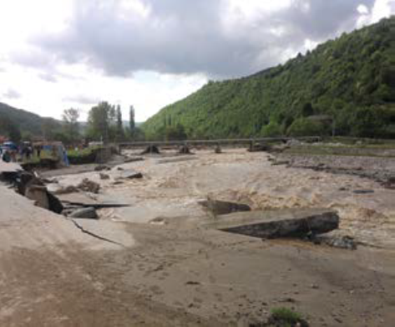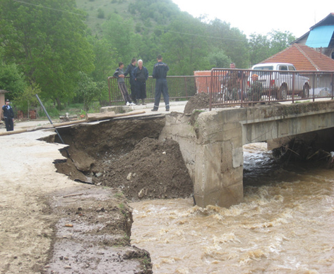
Picture2: Flood in Trgovište 2010 (Source: Blic)
As the previously described episode with the torrential flood from 2010 showed, which unfortunately took two lives, the flood on the torrential watercourses stems from the specific dynamics of torrential phenomena. The characteristic genesis and fast concentration of large waters in torrent basins make it impossible to apply classical hydro technical principles and methods of flood protection. The sudden arrival and short duration of high waters usually do not leave enough time to declare flood protection. For all these reasons, the most important defence against torrential floods is the use of preventive protection measures. The main goal of preventive measures for flood protection on torrent watercourses is, on the one hand, to reduce the probability of high water spills, and on the other hand, to reduce potential flood damage and to continuously educate the population.

LEGAL FRAMEWORK FOR DISASTER RISK REDUCTION IN CROSS BORDER REGION

Legal framework for Disaster risk reduction in Republic of Serbia

Disaster and flood defence are governed by existing legislation in the Republic of Serbia, primarily the National Emergency Protection and Rescue Strategy ("Official Gazette of RS", No. 86/2011), Law on Disaster Risk Reduction and Emergency Management ("Official Gazette of RS", No. 87/2018), Law on Emergency Situations ("Official Gazette of RS", No. 111/2009, 92/2011 and 93/2012), Law on Waters ("Official Gazette of RS", No. 30/2010, 93/2012, 101/2016, 95/2018 and 95/2018 - Dr. Law), Law on Meteorological and Hydrological Activities ("Official Gazette of RS", No. 88/10), Law on Health Care ("Official Gazette of RS", No. 25/2019), Law on Public Health ("Official Gazette of RS", No. 15/2016), Water Management Strategy on the territory of the Republic of Serbia until 2034. ("Official Gazette of RS", No. 3/2017).
The National Strategy for Protection and Rescue in Emergencies ensures the fulfilment of the European Union's recommendations for the development of national protection systems: the establishment of institutional, organizational and personnel conditions for the implementation of emergency protection; security of well-trained personnel; establishment and training of existing fire and rescue units in all places to carry out new tasks; developing the ability to respond in the event of a disaster in the most efficient way, including to eliminate the consequences of disasters caused by a terrorist attack; training of fire and rescue units of the Ministry of Interior affairs, fire fighting units in business entities and fire units of voluntary fire fighting societies, civil protection units (specialized and general purpose units); enabling citizens to act in emergencies, etc.
The Law on Disaster Risk Reduction and Emergency Management regulates disaster risk reduction, prevention and strengthening of the resilience and readiness of individuals and communities to respond to disasters, protection and rescue of people, material, cultural and other goods, rights and obligations of citizens, associations, legal entities, local self-government units, autonomous provinces and the Republic of Serbia, emergency management, civil protection functioning, early warning, notification and alert, international co-operation, inspection supervision and other issues of importance for organizing and functioning disaster risk reduction and emergency management systems. The system of disaster risk reduction and emergency management is of particular interest to the Republic of Serbia and is part of the national security system.
The Law on Emergency Situations regulates emergency management, as well as other elements necessary for the functioning of the protection and rescue system. The law precisely defines the areas of application (natural disaster and other major accidents, technical and technological accidents, protection and rescue from the consequences of terrorist attacks, etc.), as well as emergency activity holders, decision-making entities, as well as all other subjects that are relevant to emergency response. This Law also regulates the area relating to the place, role and importance of civil society organizations in the system of protection and rescue.
The law on flood defence is divided according to the categorization of waterways, so that public water utilities organize flood defence on the waters of the first order of priority, which are predominantly large waterways with built protective systems, while local governments are fully in charge of second-class priorities waterways that are mostly lush. The average municipality in Serbia has about 15 second-class waterways, some of which are regulated by protective systems, but most of them are not. According to the Law on Waters, the operational annual plan for flood defence for second-class waterways is being drafted by cities and municipalities.
The provisions of the Law on Meteorological and Hydrological Activities, among other things, specify that the Republic Hydro Meteorological Institute (RHMZ) issue notices, announcements and warnings on meteorological and hydrological elementary disasters and disasters, as well as the cross-border effects of air pollution in the event of an accident, which it then delivers to the competent emergency services and interested bodies and organizations. The RHMZ is obliged to draft and periodically revise the endangerment maps and maps of the risk of meteorological disasters and to participate in the development of flood endangerment cards based on the prescribed methodology. Within its scope, the RHMZ makes an assessment of the endangered Republic of Serbia and submits it to the ministry in charge of protection and rescue. It establishes the exclusive authority of the Republic Hydro Meteorological Institute for the development and issuance of extraordinary hydrological and meteorological information and warnings in the period before, during and after the cessation of meteorological and hydrological elementary disasters, disasters and nuclear action.
The health care law established the health care system and health service organizations, including social care for the health of the population. In accordance with this Law, the health institution is obliged to organize and implement measures in case of natural and other major disasters and emergencies. Likewise, the law establishes the Institute of Public Health for the territory of the Republic of Serbia, which determines special measures in elementary and other major disasters and accidents and implements them in cooperation with other institutions.
The Law on Public Health establishes the area of public interest from the public-health functions of the Institute of Public Health, other institutions and other participants in the preservation and improvement of the health of the population. A special chapter of this Law is dedicated to public health in elementary and other major disasters and emergencies. Thus, the Institute of Public Health is obliged to act in a timely manner in elementary and other major disasters and emergencies by proposing measures to reduce harmful effects on the health of the population, in co-operation with the authorities of state administration, autonomous province and local self-government units.

Legal framework for Disaster risk reduction In Republic of Bulgaria

The European Flood Risk Assessment and Management Directive 2007/60/EU sets the framework for the prevention of such disasters for EU Member States. Its aim is to create the basis and tools to improve and prevent flood risks, as well as to technically and economically optimize protection measures.
Directive 2007/60/EC of the European Parliament has been transposed into national legislation, in particular into the Water Act (SG No 61 of 2010).
By Order No. RD-370/16.04.2013 of the Minister of Environment and Water, in connection with Article 187, paragraph 2 of the Water Act, the "Methodology for flood threat and risk assessment" has been approved in accordance with the requirements of Directive 2007/60/EU.
The methodology was developed in accordance with Contract No. D-30-62-18.04.2012 between the National Institute of Meteorology and Hydrology at BAS and the Ministry of Environment and Water and is intended to assist experts conducting flood risk assessments in the development of hazard maps.
In accordance with the approved methodology, a preliminary risk assessment was carried out, including:
-Collect and systematize information about past floods and their adverse effects;
-Assessing the reliability of the information, digitizing it, including in GIS format, and structuring the data to enable assessment;
-Identifying significant past floods and assessed the significance of their effects;
-Analysing of the relationships between the recorded floods based on an assessment of the source of the flood, the time of occurrence the duration and the relationship between the sites on a catchment basis;
-Assessment of potential future flooding;
According to Article 146d, paragraph 1 of the Water Act, areas with significant potential flood risk (SPFRN) have been identified, and by Order No. RDD-744 /01.10.2013 of the Minister of OSW, SPFRN have been approved.
The Spatial Planning Act (SPA), promulgated in SG of 2.01.2001, in effect as of 31.03.2001, in particular Chapter Four “Networks and facilities of the physical infrastructure” and a set of ordinances issued based on SPA, is pertinent to WSS services through regulation of the investment process and the requirements for construction of WSS systems and facilities. Noteworthy is Article 87, which requires watertight tanks as the only wastewater collection solution for buildings in settlements without sewer networks.
Health Act along with the respective by-laws contains requirements for the quality of water for drinking and household needs.
The water sector in Bulgaria is regulated by a regulator that was established according to the Water Supply and Sewerage Services Regulation Act in 2005. The State Energy and Water Regulatory Commission (SEWRC) is the technical and economic regulator of WSS services in Bulgaria.
National Strategy and Action Plan for Water Sector Management and Development in November 2012. outlines the overall vision for the water sector at large, including water resources management, hydropower, flood protection, irrigation, and water supply and sanitation, which provides for a more active role of the public authorities in developing and managing the sector. It also specifies the responsibilities of the various institutions in the preparation and implementation of the sub-sector strategies and plans.
The Water Strategy has four main objectives:
- Objective 1. Guaranteed water supply to the population and business under climate change conditions leading to drought;
- Objective 2. Protecting and improving the status of surface and ground water;
- Objective 3. Improving the efficiency of integrated management of the water as an economic resource;
- Objective 4. Decreasing the risk of and damage from floods.

ENVIRONMENTAL MANAGEMENT FOR DISASTER RISK REDUCTION

Disaster risk reduction and management

Disasters are a major problem worldwide and a serious threat to sustainable development. Their impacts are diverse: as well as loss of life, injury and disease and the destruction of property and other assets, disasters can also cause social and economic disruption, loss of infrastructure and other services and damage to the environment.
Disasters result from a combination of factors: the nature of the particular hazard or hazards; the extent to which people and their possessions are exposed to them; the vulnerability of those people and assets; and their capacity to reduce or cope with the potential harm. Many diﬀerent kinds of hazard can contribute to disasters. These may be natural (e.g. floods, earthquakes, landslides, windstorms), technological (e.g. industrial and transportation accidents) or otherwise created by humans (e.g. riots, terrorist incidents and conflict).
Disasters are generally seen as extreme events in their scale or impact, requiring some form of external assistance. However, small-scale, lower-intensity hazard events can also have significant impacts locally. These small, recurrent events are usually referred to as ‘extensive risks’.
Poor communities also often face high levels of everyday risk, for example from lack of clean water and sanitation, poor healthcare, pollution, occupational injuries, road accidents, domestic fires, violence and crime. Disaster events can sometimes set back years of economic and social development gains, generate political instability and cause long-lasting environmental damage.
There are various definitions of disaster risk reduction (DRR) but it is broadly understood to mean the development and application of policies, strategies and practices to reduce vulnerabilities and disaster risks throughout society. The term ‘disaster risk management’ (DRM) is often used in the same context, referring to a systematic approach to identifying, assessing and reducing risks.
Disaster risk management (DRM) involves activities related to:
- Prevention - activities and measures to avoid existing and new disaster risks (often less costly than disaster relief and response). For instance, relocating exposed people and assets away from a hazard area.
- Mitigation - the lessening or limitation of the adverse impacts of hazards and related disasters. For instance, constructing flood defenses, planting trees to stabilize slopes and implementing strict land use and building construction codes.
- Transfer - the process of formally or informally shifting the financial consequences of particular risks from one party to another whereby a household, community, enterprise or state authority will obtain resources from the other party after a disaster occurs, in exchange for ongoing or compensatory social or financial benefits provided to that other party.
- Preparedness - the knowledge and capacities of governments, professional response and recovery organizations, communities and individuals to effectively anticipate, respond to, and recover from the impacts of likely, imminent or current hazard events or conditions. For instance, installing early warning systems, identifying evacuation routes and preparing emergency supplies.
Implementation of these activities and measures is rarely done in isolation and includes a number of associated activities, including:
- Identification and measuring disaster risk
- Education and knowledge development
- Informing people about their risk (awareness raising)
- Incorporating DRM into national planning and investment
- Strengthening institutional and legislative arrangements
- Providing financial protection for people and businesses at risk (finance and contingency planning)
- Integrating DRR across multiple sectors, including health, environment, etc.
Activities for reducing risk can be described as structural, for instance land use planning and implementation of building codes, and non-structural, for instance awareness raising, policy-making and legislation. Governments, civil society and other actors organise DRM, for example through institutional arrangements, legislation and decentralisation, and mechanisms for participation and accountability is termed risk governance.
Fundamentally, DRR succeeds in reducing risk by building the strengths, attributes and resources available within a community, society or organization – collectively known as their capacity. DRM activities are designed to increase the resilience of people, communities, society and systems to resist, absorb, accommodate and to recover from and improve well-being in the face of multiple hazards. Activities for reducing and managing risks can therefore provide a way for building resilience to other risks. In addition to development, DRM should therefore be integrated across a number of sectors, including climate change and conflict.
Resilience in reduction of risks of disasters has developed as a most important concept in disaster management. Resilience is essentially the ability of individuals to take the necessary and required steps, organize carefully, assimilate, recuperate, and most importantly, acclimate to untimely unfortunate events and occurrences. Nowadays, different authors agree that resilience tends to be one primary and important way to minimize the overall consequences of hazardous events on the affected nations as well as their different communities.
According to the Hyogo Framework for Action (UNISDR, 2005), disaster resilience is determined by the degree to which individuals, communities and public and private organizations are capable of organizing themselves to learn from past disasters and reduce their risks to future ones, at international, regional, national and local levels.
The consequences of climate changes and degradation of the ozone layer resulting from degenerative human activities will also continue making the globe exposed to disasters. Formulation of long term policies and improvement of cultural approaches towards the management and maintenance of resilience in disaster risk management are extremely important in order to enhance and advance disaster resilience to better heights.

Disaster Risk Reduction and Environmental Monitoring

With growing populations and increasing demand for food, water, energy, land, and other natural resources, the world faces a massive challenge in achieving a vision for a green, clean, and resilient development. Climate change, which is both an outcome and a driver of further environmental degradation, presents a special set of challenges. The accelerating impacts of climate change are narrowing the options for sustainable development, shortening the time frame for addressing poverty, and requiring a move toward cleaner, more efficient and equitable patterns of growth.

The local environments of many cities are affected by serious air and water pollution. Urban sprawl leads to growth in built-up areas at the expense of natural land cover and to an urban heat island effect, in which temperatures in a city are significantly warmer than in surrounding rural areas. Cities often draw heavily on resources, such as freshwater, food, and energy coming from distant sources, including other countries, thus also driving changes in land use and the environment at the global scale. Yet cities, if planned and managed well, are efficient energy and resource users as well as sources of innovation, jobs, and growth (World Bank 2010.).
The rapid loss of biodiversity combined with shrinking habitats and deteriorating ecosystem infrastructure, such as forests, has fundamentally altered ecosystems that generate an array of benefits: provisioning services such as food and water, regulating services such as ﬂood and disease control, cultural services such as spiritual and recreational activities, and supporting services such as nutrient cycling and carbon storage. Together, these services maintain the conditions for life on Earth. While the use of ecosystem services is growing, the capacity of ecosystems to provide these services has declined significantly.
Resource use must be sustainable. It is the responsibility of the people to ensure that the way resources are used today is not compromised their availability tomorrow.
Population, especially communities living around area rich in natural resources, must be included in management and conservation of natural resources. Communities must be involved in the development of policies and regulations to ensure sustainable resource use. They must have a sense of ownership and responsibility in resource management and participate in the distribution of benefits they get by using it.
Sometimes human activities consciously impact the environment, such as through deforestation for timber. But mostly human activities have negative impacts on the environment as a consequence of the way they are carried out. For example, energy production, industrial development and expansion of agricultural lands are all necessary activities to meet the needs of our growing global population, but these activities emit greenhouse gases and other pollutants causing climate change, acid rain and air pollution, contribute to biodiversity loss and depletion of water resources, which lead to a host of other environmental problems.

MOST FREQUENT NATURAL DISASTERS IN CROSS – BORDER REGION

Floods

The most frequent natural disasters in Balkan region are flooding on major rivers and torrential (flash) flooding. This is conditional due to the position and relief of Balkan. Flooding is temporary water cover for land that is not usually covered with water. This includes flooding caused by rivers, mountain streams, torrential waterways, as well as sea-induced flooding in coastal areas. The previous definition was given in the Flood Risk Assessment and Management Directive, and it is noticeable that floods are caused by spills of water from sewage systems, be they atmospheric, sanitary or industrial.
Natural phenomena such as rainfall and melting snow in the upper reaches of the basin are the most common causes of flooding on both large rivers and torrential waterways and streams. The anthropogenic influence is mostly related to activities in the waterway itself, but also the watershed. Deforestation, construction of buildings and roads, channelling and other activities increase the speed of swelling and the amount of swollen water from the watersheds, and shortens the concentration time of water in the main trough, i.e. increases the swelling ratio from the watershed. Changing riverbeds and building objects on the shores or even in the trough of waterways, reduces the flow time through the trough, but also reduces the flow profile, increasing the height of the water in the trough.
Anthropogenic influence is also expressed by the construction or narrowing of the riverbed (constitutions, dams, bridges), causing the formation of a flood lake upstream from the bulkhead. Apart from these people, their negligence towards the environment affects the emergence of floods and depositing construction kicks, as well as all other types of waste in the waterway.
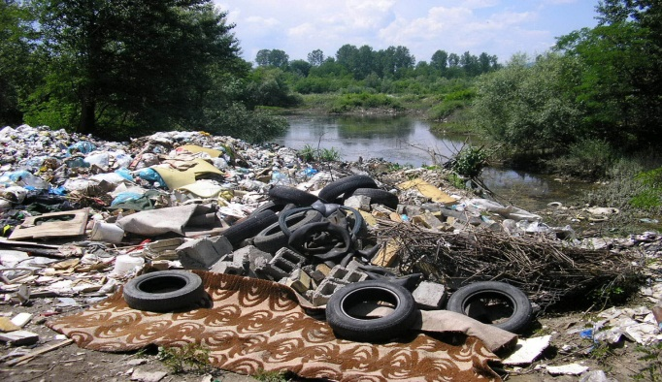
PICTURE 3: Anthropogenic influence (Source: Blic)
Due to global climate change, flooding is increasingly caused by heavy regional rainfall. On the other hand, torrential rains are caused by high-intensity rains falling from clouds known as cumulonimbus, which are also the cause of the rainfall. The city is affected by a proportionately narrow area of 100m to 300m, while rain from these clouds covers an area of 10 km² to 30 km². What is worrying is the emergence of cumulonimbus systems, which cover an area greater than 600 km², with extremely heavy precipitation in a short time (1 – 5 hours), a characteristic of the tropical climate. Such rains turn proportionately large rivers into destructive torrents, which, in addition to destroying everything in their path, also bring human casualties. Given the prevalence of mountainous areas in Balkan and the developed hydrographical network, torrential flooding occurs very often, almost every year. The development of large waters takes place in the upper part of the watershed, while flooding occurs in river valleys, in the lower stream. In this regard, it should be noted that the lower streams of most lush waterways in Balkan, with developed river valleys, have great social and economic significance. These valleys contain a large number of urban and rural settlements, as well as significant transport infrastructure. Most river valleys have agricultural purposes, while industrial zones are often located next to settlements. This means that floods threaten very valuable goods offshore – settlements, roads, agriculture and industry.
When it comes to flash flooding, it is more right to talk about "torrential processes", rather than floods, because it is really a set of phenomena that take place in a lush waterway and coastal, when a wave of large waters comes in. In addition to spilling large waters from the trough, there are also phenomena of torrential lava, landslides and landslides. Torrential waves are linked to another phenomenon, which has a major impact on the scale of the phenomenon, which can only be tentatively called flooding. Namely, due to the sudden rise of large waters, the torrential waves have a very pronounced steep forehead of the so-called "big water".
According to statistics, periods of flooding during the year in Balkan vary mainly by the size and character of the watershed. On the large plains, flooding occurs most often during the period of early spring and spring, depending on the temperature characteristics in the upper streams of rivers, i.e. from the melting of the snow cover in higher watershed zones. On smaller waterways, flooding occurs during periods of prolonged and intense rain, mainly in spring and autumn, which again depends on the weather conditions in the watershed. In contrast, small and torrential waterways occur most often during summer, because heavy rainfall is most common, although waterways of this type are not rare in late winter and early spring flooding due to the sudden melting of the snow cover. A particular type of flooding is ice-induced flooding– ice barriers.
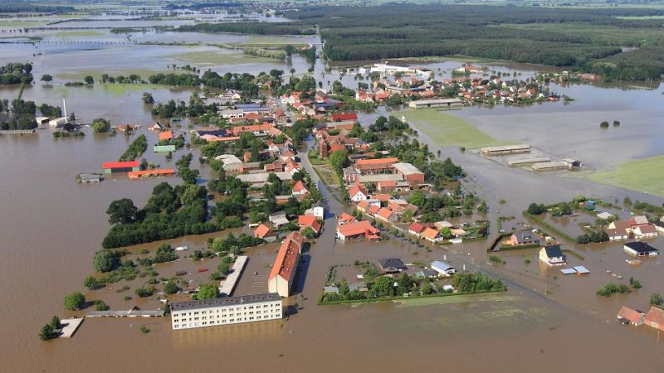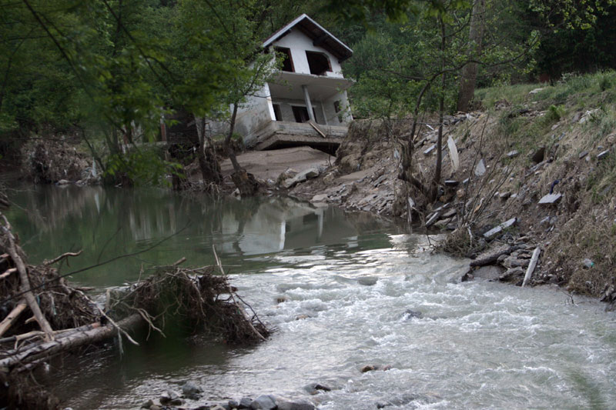
Picture 4. : Flooding in plain and mountainous regions, differences (Source: Blic)

Flash flood and soil erosion

Flash flood and soil erosion are natural phenomena that occur together. The pronounced effects of climate factors, such as rain showers and storms, cause torrential flooding, which are manifested by devastation, high rate of formation and short duration. On the other hand, there is an imperceptible effect of climate factors that manifests itself as a process of soil erosion. Erosion processes are difficult to detect and slow and are usually found only when large surfaces are bare and then the problem of erosion becomes difficult to solve or an insoluble problem. Under the term erosion in the elemental sense, changes should be implied on the surface layer of soil relief, which occurs as a result of the effects of rain, snow, temperature differences, wind and running water, or due to the work of anthropogenic factors. The intensity of erosion depends on the four main factors. Three factors represent the natural characteristics of the area: geological surface, relief and climate, while the way of using the soil is a factor that is largely under human control, which is why it is susceptible to dynamic and rapid changes.
The map of erosion is an important document because it clearly identifies surfaces that, from the erosion risk aspect, are erosion and potentially erosion areas, for which restrictions and terms of use are defined, prescribe preventive measures and prioritize the necessary anti-erosion works, from which the importance of having an up-to-date ticket is arising.

Climate change

Anthropogenic greenhouse gas emissions have increased since the pre-industrial era, driven largely by economic and population growth, and are now higher than ever. This has led to atmospheric concentrations of carbon dioxide, methane and nitrous oxide that are unprecedented in at least the last 800,000 years. Their effects, together with those of other anthropogenic drivers, have been detected throughout the climate system and are extremely likely to have been the dominant cause of the observed warming since the mid-20th century.
Total anthropogenic GHG emissions have continued to increase over 1970 to 2010 with larger absolute increases between 2000 and 2010, despite a growing number of climate change mitigation policies.
Anthropogenic GHG emissions in 2010 have reached 49 ± 4.5 GtCO₂-eq/yr. Emissions of CO2 from fossil fuel combustion and industrial processes contributed about 78% of the total GHG emissions increase from 1970 to 2010, with a similar percentage contribution for the increase during the period 2000 to 2010.
Globally, economic and population growth continued to be the most important drivers of increases in CO2 emissions from fossil fuel combustion. The contribution of population growth between 2000 and 2010 remained roughly identical to the previous three decades, while the contribution of economic growth has risen sharply. Increased use of coal has reversed the long-standing trend of gradual decarbonisation (i.e., reducing the carbon intensity of energy) of the world’s energy supply.
Evidence of observed climate change impacts is strongest and most comprehensive for natural systems. In many regions, changing precipitation or melting snow and ice are altering hydrological systems, affecting water resources in terms of quantity and quality. Many terrestrial, freshwater and marine species have shifted their geographic ranges, seasonal activities, migration patterns, abundances and species interactions in response to on-going climate change.
Changes in many extreme weather and climate events have been observed since about 1950. Some of these changes have been linked to human inﬂuences, including a decrease in cold temperature extremes, an increase in warm temperature extremes, an increase in extreme high sea levels and an increase in the number of heavy precipitation events in a number of regions.
Continued emission of greenhouse gases will cause further warming and long-lasting changes in all components of the climate system, increasing the likelihood of severe, pervasive and irreversible impacts for people and ecosystems. Limiting climate change would require substantial and sustained reductions in greenhouse gas emissions which, together with adaptation, can limit climate change risks.
Both Bulgaria and Serbia are situated in one of the regions that is particularly vulnerable to climate change (mainly through temperature increase and extreme precipitation) and to the increased frequency of climate change-related extreme events, such as droughts and floods. The risks inflicted by climate change-related events may lead to loss of human life or cause considerable damage, affecting economic growth and prosperity, both nationally and trans-boundary.
Consensus exists in the scientific community that climate change is likely to increase the frequency and magnitude of extreme weather events. Over the past decades, this frequency has increased significantly. The most common hydro meteorological and natural hazards are extreme precipitation and temperatures, storms, floods, wildfires, landslides, and droughts.

Fires and wildfires

Fires belong to the technical-technological group of elementals disasters in which man participates. It's a process uncontrolled life-threatening combustion and human health, material goods and the environment.
Fire is an unstated burning process that is takes place in a certain space and time, and for whose the following conditions must be met:
• Existence of combustible matter;
• Continuous contact of oxygen in the fire zone and
• Energy required for fire generation and release thermal energy.
All these conditions can be found under the name "fire triangle".
It is necessary to make a difference in the understanding of burning and fire. Burning is a controlled process that takes place in a certain way place, in a certain period and under a certain heat regime, while fire is an uncontrolled phenomenon that takes place beyond the interests of society, and as a result there are great mortals cases of people and inflicts great material damage.
Balkan Peninsula every year is confronted with fire danger in a wild land due to weather conditions: drought, heat, and wind participate in drying out the timber or other fuel, making it easier to ignite. Once a fire is burning, drought, heat, and wind all increase its intensity. Topography also affects wildfire, which spreads quickly uphill and slowly downhill. Dried grass leaves, and light branches are considered flash fuels; they ignite readily, and fire spreads quickly in them, often generating enough heat to ignite heavier fuels such as tree stumps, heavy limbs, and the organic matter of the forest floor. Such fuels, ordinarily slow to kindle, are difficult to extinguish.
Green fuels—growing vegetation—are not considered flammable, but an intense fire can dry out leaves and needles quickly enough to allow ready ignition. Green fuels sometimes carry a special danger: evergreens, such as pine, cedar, fir, and spruce, contain flammable oils that burst into flames when heated sufficiently by the searing drafts of a forest fire. Wildfires are fanned by winds and often follow the air currents over hills and through valleys. Fires in Europe occur frequently during the hours of 12:00 p.m. and 2:00 p.m.
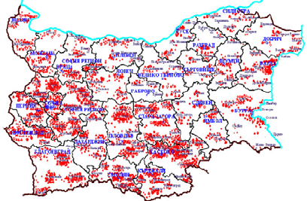
Figure 10. Bulgarian forest fires in the period 1994-2006 (Source: WRF-Fire wildfire modeling in the test area of Harmanli,Bulgaria Nina Dobrinkova, Georgi Jordanov)
Wildfires release large amounts of carbon dioxide, black and brown carbon particles, and ozone precursors such as volatile organic compounds and nitrogen oxides into the atmosphere. These emissions affect radiation, clouds, and climate on regional and even global scales. While direct emissions of harmful pollutants can affect first responders and local residents, wildfire smoke can also be transported over long distances and impact air quality across local, regional, and global scales. Over the past century, wildfires have accounted for 20-25% of global carbon emissions, the remainder from human activities. Global carbon emissions from wildfires through August 2020 equalled the average annual emissions of the European Union.

Earthquakes

Amongst natural disasters, earthquakes are one of the most lethal kinds due to their unpredictable nature and devastating impact they can have in a matter of seconds. The planet Earth is very active in terms of changes in temperature, pressure, magma, as well as the movement of rocky parts of the Earth's crust in terms of rising or falling individual blocks and horizontal movements with pulling or underlining certain blocks, as evidenced by daily vibrations, earthquakes they feel on the very surface of our planet. The igneous, tectonic and metamorphic movements of our planet are slow and long-lasting, while the movements in the form of earthquakes and tremors of the Earth's crust and its surface are short-lived and sudden. Earthquakes are underground shocks and vibrations of the Earth's surface, caused mainly by tectonic processes. Earthquakes are sudden explosive releasing the enormous pressures that are accumulate in the earth's crust.
Earthquakes in the Balkans occur for several reasons, primarily due to the interaction of tectonic plates that occurs under the Adriatic Sea where the convergent border is located, i.e. one plate is underlined under the other. Floods may be secondary effects of earthquakes, if dams are damaged. Earthquakes may cause landslips to dam rivers, which collapse and cause floods.
They can occur anywhere, at any time and impact differently depending on their magnitude, the season, the built environment, the time of day, causing a wide range of potential consequences on population. This makes them a matter of political and humanitarian concern for health practitioners, policymakers and the hazard management community. The Balkans is considered one of the most turbulent areas in Europe.

SWOT ANALYSIS

It is becoming clear that environmental degradation is one of the underlying causes of disaster risk. Ample evidence indicates that better environmental information and/or environmental management could effectively support disaster risk reduction, post-disaster response and environmental and humanitarian recovery efforts. This has led to increased understanding of the contributions that natural systems make in reducing the impacts of disasters, the environmental consequences of disasters and of post-disaster recovery. But recent initiatives have focused almost exclusively on the social and development aspects of risk, emphasizing human vulnerability to hazards, and forgetting the vital component played by the environment in causing or reducing that vulnerability.
Water is an important element of the geographic environment that influences other elements and also the lives and economic activities of people. They are important for the formation of the topography, for the water supply of settlements, for artificial irrigation, for the production of electricity. Water resources are an important condition for the economic development of any region.
Both territories Trgovište and Kostinbrod municipality falls in an area identified with significant potential flood risk. Preventive measures to protect against floods are integrally implemented in the documents prepared by municipalities that are tackling flood protection.
The common characteristic of almost all torrent watercourses in the area of ​​Trgovište and Kostinbrod are in poor ecological condition. This condition is caused by the interaction of natural and anthropogenic factors. Natural factors are mainly manifested by the growth of vegetation in the riverbed and on the banks of watercourses, as well as the effects of the passage of large water waves. Broken trees and branches, which are carried at the head of the waves of great waters, remain on the existing vegetation in the riverbed. This creates natural barriers, which greatly reduce the capacity of the riverbed.
The influence of anthropogenic factors is manifested in two ways. The first refers to the absence of any measures and works to eliminate the negative effects of natural processes. No cleaning, removal or thinning of vegetation in the riverbed and on the banks is performed. The second refers to the negligence of citizens who often throw things into riverbeds that they no longer need which not only creates illegal dumps on watercourses, but also reduces their capacity, which directly affects the occurrence of floods when creating large waters.
Both municipalities have the problems of building residential and commercial buildings in the immediate vicinity of the riverbed, construction of intersections of watercourses and roads, with insufficient capacity for high waters, thus reducing the possibility for natural flow of high waters.
In the last couple of decades, there has been a trend to build houses and buildings near rivers, especially in suburban areas. It indicates insufficient education of the population regarding torrents, and also speaks of poor urban planning, i.e. the lack of it. The disorder of the road infrastructure, with the lack of rain and sewage and ditches, especially in the steeper parts of the settlement, causes runoff of torrential waters on the road surface, soil erosion and accumulation of significant amounts of sediment in the downstream part.
A large number of settlements are located in the basin of torrent watercourses, but fortunately they are mostly located outside potential floodplains. This is especially pronounced in rural settlements. The construction of culverts at the intersections of watercourses and roads, with insufficient capacity for high waters, causes frequent congestion, spills and traffic interruptions. This problem has been noticed on most rural roads, which were built without respecting standards and regulations.
The provision on declaring erosion areas has long been in force, and all obligations arising from it must be implemented by local self-government. The problem with local governments is the very expensive work on rehabilitation of the erosion of destroyed land due to the complexity, difficult accessibility of the terrain on which the works are carried out and the necessary high expertise in the design and execution of works. Development of erosion processes in erosion areas is mitigated by the implementation of anti-erosion measures prescribed to owners and land users in the erosion area. These measures are simple and consist of bans and obligations.
Although waste management in Kostinbrod is fully in line with EU principles, mayor issue concerning environmental risks in Trgovište is a non – sanitary landfill. It is located in the southeast part of Trgovište in a place called "Crna Dolina" in the settlement of Donja Trnica next to the regional one road Trgovište-Vranje. The landfill is of an open type, so the waste is collected by the Utility Company “Komunalac” and also by citizens. The non-sanitary landfill is in operation since 1992. and no measures of protection are implemented at the location. Without even minimum protection measures, it represents a huge risk to the environment and human health. This situation will be addressed in Action plan with special measures developer just for Trgovište.

Strengths | Weakness
- Both municipalities have operational plans in place  - Good cooperation established in implementing development projects at regional level  - Civil protection units in Kostinbrod functional | - Poor maintenance of watercourses  - Illegal dumps on watercourses  - Vulnerable groups are not identified  - Communities are completely unprepared and adapted to disasters  - Policy and legal framework to mainstream DRR into development plans are not in place  - Monitoring of environmental parameters is not established in Trgovište  - Civil protection units in Trgovište are not established
- Preventive measures to protect against flood adopted  - Facilities for active flood protection are being acquired  - Better communication with stakeholders at all levels  - Exchange of good practices at cross – border level | - Both territories Trgovište and Kostinbrod municipality falls in an area identified with significant potential flood risk.  - Insufficient finance  - Communities not interested in participation
Opportunities | Threats
Table 3. SWOT Analysis

It is necessary to regularly maintain existing facilities, bridges, culverts, embankments, canals, ditches, etc. on all categorized and uncategorized roads and public areas in good condition and perform grassing and afforestation of areas in vicinity of rivers.
In order to prevent floods, it is crucial to take measures through the local community to organize and indicate the need for each household to clean part of the riverbed from stumps, branches, shrubs and other waste material during spring works on agriculture, whose property is located by the river, then to build local barriers around the endangered areas that would be maintained for large-scale floods by maintenance from year to year. This action would be especially effective if the neighbouring households were united, so in that case, preventive protection measures would cover larger areas.
The prescribed prohibitions in order to prevent erosion are: leaf cutting, farming on steep fields, clear logging of forests in lean terrain, grazing on degraded grassland. Whereas the obligations: plugging into isohips, turning degraded fields into meadows, meliorating degraded pastures, foresting, converting one-year-olds into perennial cultures on degraded surfaces, anti-erosion land farming, anti-erosion farming of forests.
These measures are prescribed for each individual parcel located in the erosion area without reducing the income of the user from that area. Today, the areas where administrative anti-erosion measures have been implemented are known for the production of nuts, blueberries, blackberries, raspberries, herbs and other profitable products. The population was just finding new successful solutions, which were soon accepted as standard. In this way, forest and fruit plantings were erected in parts of Serbia that were severely damaged by erosion, on parcels where the implementation of administrative measures could drastically reduce the intensity of erosion. Relief, geological surfaces susceptible to erosion, a climate characteristic of high-intensity rains and parts of the country where strong winds occur are a great basis for creating torrential and torrential floods, and they are common in Serbia. For this reason, flood protection facilities have also been built.

PRIORITIES OF THE JOINT ACTION PLAN

The purpose of implementing the activities set out in this action plan is to build community resilience by promoting and raising public awareness of the importance of risk reduction as an integral component of sustainable development, thereby reducing human, social and economic and environmental losses disasters, technological disasters and environmental disasters.
Priority areas:
Priority area 1: Establish a local framework for resilience and environmental protection
Specific objective 1: Integrating risk resilience into policy and planning for sustainable community development.
Specific objective 2: Implementation of joint activities on the inclusion of risk reduction policy in strategic, development and planning documents.
Priority area 2: Understanding risks and preventive action
Specific objective 1: Identified vulnerable population and habitats by areas and target groups
- Preparation of a preliminary assessment of the degree of endangerment of certain areas and assessment of the number of endangered population;
- Development of a map of endangered areas and a database of endangered population according to vulnerable groups;
Specific objective 2: Raised the level of knowledge for understanding the causes and consequences of risk and awareness of the importance of taking preventive measures to reduce risk.
- Preparation and implementation of research on the level of knowledge and readiness of the population to participate in activities to reduce the risk of disasters
- Preparation of training programs for certain target groups and for certain areas and priority topics;
- Implementation of education programs for different target groups according to different areas and priority topics;
- Conduct public awareness campaigns on disaster risk prevention measures
Priority Area 3 - Improving population preparedness for disaster response and post-emergency recovery by raising knowledge levels
Specific objective 1: Improved information and early warning of risks
- Establishment and testing of mechanisms for exchange of information and communication between stakeholders in the territory of local self-government on risks and actions during and after emergencies;
- Inclusion of information and instructions on activities, procedures and procedures for response during and after emergencies in training programs and campaigns for raising public sanctity.
Specific objective 2: Increased population readiness to respond to emergencies and rapid recovery after them
- Involvement in training activities
Priority Area 4 - Improving the capacity to protect the environment and use knowledge and innovation to build a culture of safety and reduce disaster risk
Specific objective 1: Strengthened cooperation between the municipalities of Kostinbrod and Trgovište, civil society organizations in the country and the region and increased capacity of partners in the field of disaster risk reduction.
- Exchange of experiences and examples of good practice with other cities and projects;
Specific objective 2: Monitoring of environmental parameters established in order to increase the resilience of communities
- Establishing monitoring of environmental indicators and reporting on implemented activities in the field of disaster risk reduction;
- Environmental evaluation and ecosystem re-establishment

ACTION PLAN FOR PERIOD 2022 – 2027.

  - Urban Environment Sector
Strategic objective | Operational objective | Activity | Expected results | Indicators | Duration
Integrating risk resilience into policy and planning for sustainable community development | Improve the legal and public policy framework to reduce the risk of disasters | Revise and include disaster risk reduction principles in documents related to environmental, spatial and urban planning | Principles of disaster risk reduction and environmental protection included in local policies | Number of documents updated:1 | 2025
 | Technology/ Construction - Implement new DRR norms in planning, design, construction technologies, and building materials | Stimulate creative urban design, resilient to climate change through annual competitions and awards  Promote green, smart, and innovative cities, buildings and technologies planning, design and certification; | Better construction and maintenance supervision, monitoring and control, leading to more resilient and healthier environment | Number of competitions: 2 | 2024
Enhance knowledge management, research, education and stakeholder communication for adaptation | Provide open access to information for the general public | Better informed general public and higher DRR awareness, more appropriate public participation | Established open access DRR platform | Number of users at least 50 | 2023
 | Provide common long-term vision and objectives in urban environment DRR research | Identify priority scientific topics, linked with the city, open and green spaces, buildings, infrastructure, construction materials and human health, and their risk resilience assessment | Informed decision making, created joint community vision | Number of new priorities set; | 2024
 | Partnership - Work in partnership and communicate knowledge | Promote partnership, networking, and collaboration among different age, gender, ethnicity, professional, and social groups, including the disadvantaged ones | Identified problems, needs, and stakeholders, improved cooperation  Organize a social network for support of vulnerable groups | Published results  Network created | 2025
Strengthen knowledge base and awareness for adaptation | Enhance awareness, education and training | Prepare and carry out DRR trainings of public administration and operators  Prepare and carry out DRR trainings of general public | Increased preparedness of the stakeholders | 5 trainings conducted | 2024

  - Biodiversity and Ecosystems Sector

Strategic objective | Operational objective | Activity | Expected results | Indicators | Duration
Enhance ecosystem governance | Align strategic planning and implementation legislation | Review and amend legislation and secondary legislation in the environment sector and related sectors to reflect the DRR needs with regard to with regard to ecosystem-based management, conservation, restoration and resilience | Provisions for implementation of ecosystem-based adaptation in line with DRR measures | Number of revised documents :1 | 2024 - 2026
 | Link decision making, resource, and funding to efficient assessment of improved ecosystem condition | Ecosystem mapping and assessment, monitoring, self-monitoring, EIA, and other available data is taken into account in all revised DRR strategies | All funding instruments for the program periods beyond 2027 to include clearly measurable, ecologically sound objectives and indicators for ecosystem conservation/ restoration, monitoring and management, and the requirement during the eligibility check that eligible projects are to contribute toward the ecosystem-based DRR | New provisions for management plans of protected areas, green infrastructure | 2025 - 2027
Enhance knowledge management, education and stakeholder communication for DRR | Improve communication and understanding of ecosystem processes and climate change as pressure | Communication and tools for informed prioritization of research and practical action | Innovative approach in environmental management and DRR | Number of innovative tools: 1 | 2024
 | Restore, enhance, and use local biodiversity protection for improvement of DRR knowledge | Targeted collection of folk customs and traditional knowledge  Promote ecosystem thinking among volunteers | An open library of ecologically sustainable traditional practices for DRR, volunteer training | Base of traditional knowledge  Trained volunteers: 20 | 2023
 | Educate for ecosystem monitoring for DRR | Implement new training programs at all educational levels and in informal/non-formal education | All aspects of ecosystem knowledge, awareness, management, monitoring and use of ecosystem services (including ecosystem restoration for CCA) are covered by appropriate parts of the education system | Number of training conducted: 3 | 2025
Create space for Biodiversity and Ecosystems for DRR | Reclaim space from grey infrastructure to reduce fragmentation and create natural paths for disasters | Local development and equitable access to ecosystem services | Implementation of activities on track and monitoring for the overall achievement | Area of reclaimed space | 2027

Waste management in Trgovište

Strategic objective | Operational objective | Activity | Expected results | Indicators | Duration
Improving communal hygiene and infrastructure for responsible waste management | Rehabilitation, closure and remediation of non – sanitary landfill | Preparation of main project of remediation, closure and reclamation of the non - sanitary landfill  Exploring the possibilities of gaining finance from Ministry of environmental protection for documentation or works  Conduct works on implementation of the project | Preparation of all necessary documentation and approval for works | Main project prepared  Landfilled closed and monitored | 2022 - 2025
 | Improving coverage for collection of municipal waste and introducing separate waste collection | Improving public hygiene try service of waste collection in villages, especially those in proximity of rivers to prevent floods  Opening of collection point for separate waste collection | Prevention of illegal dumps forming  Lowering possibilities of greater risk from floods  Separate waste collection system built | Decrease of illegal dumps for at least 40%  At least 80% of coverage with service of municipal waste collection | 2022 - 2027
Enhance sustainable waste management, education and public participation | Improve local legal framework for waste management and participation in the community | Education and public campaigns  Adoption of new Local waste management plan for 2023 – 2033  Joining Pčinja region for waste management  Enforcement of local legal framework for waste management | Preparation of the new legal framework for waste management in Trgovište  Preparing decisions for joining region for waste management  Public informed and included in the process | Local plan for waste management adopted  “Meteris” sanitary landfill for depositing of waste used  A least 3 public debates held | 2023 - 2025

Literature:
- Water Management Basics of the Republic of Serbia, REPUBLIC OF SERBIA MINISTRY OF AGRICULTURE, FORESTRY AND WATER MANAGEMENT
- Water management strategy on the territory of the Republic of Serbia until 2034 ("Official Gazette of RS", No. 3/2017)
- Local community and the problem of torrential floods, Milutin Stefanović, Institut za vodoprivredu „Jaroslav Černi”, Beograd Zoran Gavrilović, Institut za vodoprivredu „Jaroslav Černi”, Beograd mr Ratko Bajčetić, Udruženje bujičara Srbije, Beograd
- Watercourse management, Marina Babic-Mladenović
- OPERATIONAL PLAN FOR DEFENSE AGAINST FLOOD ON ROWS ON THE TERRITORY OF THE MUNICIPALITY OF TRGOVIŠTE FOR 2021
- Preliminary flood risk assessment - Republic of Serbia, Ministry of Agriculture, Forestry and Water Management REPUBLICAN WATER DIRECTORATE
- Strategy for Development and Management of the Water Supply and Sanitation Sector in the Republic of Bulgaria 2014 – 2023
- Assessment and Mapping of Soil Erodibility and Rainfall Erosivity in Bulgaria, Svetla S. Rousseva, Vihra Stefanova N. Poushkarov Institute of Soil Science Sofia, BULGARIA
- PROGRAM FOR THE ENVIRONMENTAL PROTECTION OF KOSTINBROD MUNICIPALITY FOR THE PERIOD 2021-2025.
- PORTFOLIO OF THE VOLUNTEER FORMATION "FENISK"- G. COSTINBROD
- INTEGRATED DEVELOPMENT PLAN FOR THE MUNICIPALITY OF KOSTINBROD FOR THE PERIOD 2021-2027
- National Climate Change Adaptation Strategy and Action Plan of Republic of Bulgaria
- International Strategy for Disaster Reduction (ISDR) (2005). Hyogo Framework for Action 2005-
- 2015: Building Resilience of Nations and Communities to Disasters. World Conference on
- Disaster Reduction, January 2005, Kobe, Hyogo, Japan.
- Disaster resilience: Topic guide. Birmingham, UK: GSDRC, University of Birmingham.
- https://www.independent.co.uk/climate-change/news/climate-crisis-fires-global-heating-amazon-california-eu-a9690146.html
- WRF-Fire wildfire modeling in the test area of Harmanli,Bulgaria Nina Dobrinkova, Georgi Jordanov
- ISDR and UNEP (2007). “Environment and Vulnerability: Emerging Perspectives.”
- https://climate.copernicus.eu/climate-bulletins
- https://effis.jrc.ec.europa.eu/
- UNCCS (United Nations Climate Change Secretariat). 2017. Opportunities and options for integrating climate change adaptation with the Sustainable Development Goals and the Sendai Framework for Disaster Risk Reduction 2015–2030, Technical paper, UNCCA. https://unfccc.int/sites/default/files/resource/techpaper_adaptation.pdf
- UNECE (United Nations Economic Commission for Europe). 2017. Environmental Performance Reviews, Bulgaria, Third Review, UNECE.
- WHO (World Health Organization). 2009. Improving Public Health Responses to Extreme Weather/Heat-Waves – EuroHEAT, Technical Summary, Copenhagen: WHO Regional Office for Europe, 60.

Source: Operational plan for flood defense on waters of the second order on the territory of the Municipality of Trgovište for 2021
Flood Assessment and Management Directive – Directive 2007/60/EC of the European Parliament and of the Council on the assessment and management of flood risks.
Source: Local Community and Flood Milutin Stefanović, Institut za vodoprivredu „Jaroslav Černi”, Beograd Zoran Gavrilović, Institut za vodoprivredu „Jaroslav Černi”, Beograd mr Ratko Bajčetić, Udruženje bujičara Srbije, Beograd
https://www.independent.co.uk/climate-change/news/climate-crisis-fires-global-heating-amazon-california-eu-a9690146.html

